**Telecommunication Services System**

**Group**

Nishi Manoharan – 2088785

Ali Habib - 2115858

Mololuwa Obafemi-Moses – 2130433

**Introduction**

**Deliverable 1: Company Background**

1. Name of Company: PrecPearl Limited.

It is a Techno-telecommunications company that provides technical solutions and services to telecommunication companies. It also provides fiber optical implementation and Maintenance services to Internet Service Providers (ISP).



Website Link: https://precpearl.com/

1. Company Background:

Privately owned, formed and operates in Nigeria Since 2003 as an Enterprise and presently with 10,000,000 shared capital(Private Limited).

Offices in Yaba Lagos, and Accra with over 110 key Engineering and Management personnel.

Company’s resources and experience are the foundation for a complete, Engineering Design, Oil & Gas, Project Management, Maintenance Services, Personnel Supply and Procurements Services.

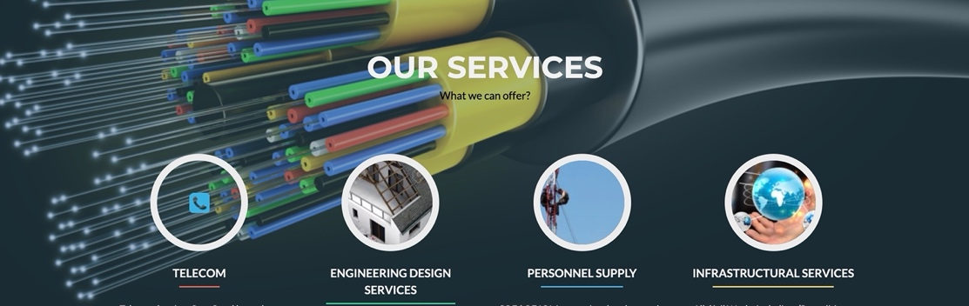

Company Mission/Strategic Plan:

To become one of the Leading and Most Sought Nigerian Optic Fiber, Telecoms, Construction Companies in Nigeria and West Africa and it recognize the route to Realizing this Vision is with a team of competent staff,  totally committed to serving the industry with professionalism, high quality and efficient service while always striving for excellence.

Its customers include telecommunication companies, internet service providers, and fiber construction companies.

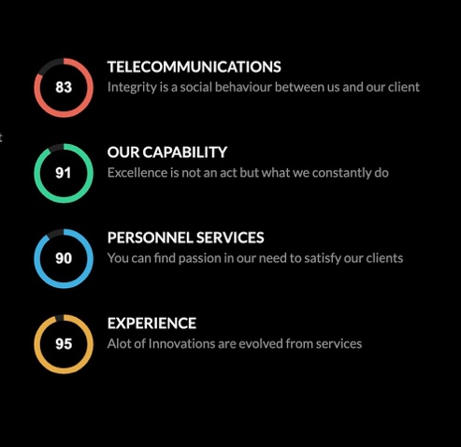

1. Organizational resources and processes:

Human resource: The company has a work force of over 500 people.

Physical resources: The company owns several equipment such as Splicing machines, OTDR, Power meter etc.

Intellectual resources:

Financial resources: The company is currently evaluated to be worth over $4 million.

1. Three systems that are not computerized:

Having identified the following processes that are not computerized, we have been able to come up with the following systems in other to improve performance and efficiency at the company

* The knowledge base system:



* The company has an inefficient documentation process so we are proposing a system to efficiently capture this process in other to improve and support decision making.
* The ticket tracking system



* The company experiences a challenge with communication as regards tracking of tickets between the technical experts, project manager and customers so we are proposing a tracking system that monitors, manages and maintains outages in real time.
* Finance/Expense reimbursement system



* The delay in daily expense reimbursement due to the manual submission of expense sheets, as it has to go through several authorities before approval so we are proposing a reimbursement system that automates this process.